2019 SAMSUNG RESEARCH PROGRAM

Samsung Vietnam Mobile R&D Center (SVMC) now opens to receive research ideas and proposals from professors of Vietnamese universities with 2 Programs of Technology Research and CSR Project Research (university/college students also can apply). These proposals shall provide advanced software technologies or services to Samsung mobile devices.
Process
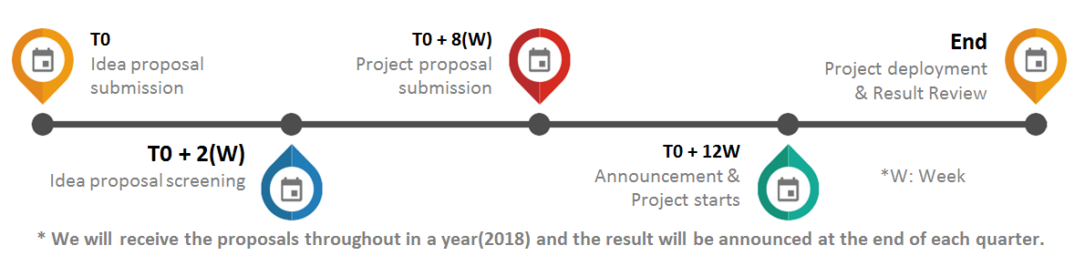
Applications must include
- Full curriculum vitae with a list of past projects and publications
- Comprehensive analysis of target problem, technical solutions and deployment plan
Confidential and Proprietary Information
Participants shall ensure no confidential or proprietary information is included in submitted proposals. Proposals shall be treated as non-confidential and non-proprietary.
Content | Technology Research Project | CSR Project Research
Evaluation Criteria | - Innovation: Possibility to bring new experiences or technologies to mobile users.  - Commercialization: Application in wide-range of user scenarios in commercialization products respect to the timeline, objectives, and resources available.  - Value to Samsung's Business: Values to Samsung by increasing value of mobile products or of intellectual properties. | Projects aim at supporting specific groups within societies should include:  - Innovation: Possibility to bring new experience or fundamentally remove difficulties.  - Applicability: Efficiently applicable to targeted group respecting to the timeline, and resources.  - Value to Society: High level of recognition and visibility when deployed to society.
Project Themes | - Machine Learning & NLP supporting smart interaction and decision making.  - IoT solutions including connectivity platforms and advanced IoT services.  - VR and AR technologies and its application to specific business.  - Differentiated services for mobile users in Southeast Asia region. | - Projects shall help specific groups (deaf/dumb/blind communities) or disadvantaged groups (unemployed/older people, young person with difficult circumstances, street children…) and specific social issues (traffic jams, health, environment..)  - Apply unique technology to support people and society and promote sharing values, VR Technology is preferable.  - Differentiated services for accessible for all individuals.  - Categories: education, medical & health, community, environment &safety
Contact Point | DO THI KHANH VAN  Email: dokhanh.van@samsung.com  Tel: 090 463 2211 | NGUYEN MAI LINH  Email: mai.linh@samsung.com  Mobile : 0913 67 4348

